Multicasting on OpenWrt

This document will explain how to set up your OpenWrt router to use multicasting. This tutorial in part assumes you followed the “OpenWRT Router Setup on VirtualBox” documentation

**NOTE : To open and edit a file from your OpenWrt router, enter the following commands:**

To open the file in vim → **vim [file name]**

To enter writing mode → **Shift + i**

To exit writing mode → **Esc**

To save your changes and quit vim → **:wq!**

## Step 1: Install igmpproxy

The OpenWrt router must act as a router for multicast packets and igmpproxy does this by listening for and proxying the IGMP requests to the ISP as well, and then enabling forwarding of the UDP packets from WAN to LAN. To do this, you will need to install igmpproxy. [Here is more information about igmpproxy and how it works with OpenWrt](https://openwrt.org/docs/guide-user/network/wan/udp_multicast)

On your OpenWrt run the following command:

**opkg install igmpproxy**

Now, you will need to edit the file **/etc/config/igmpproxy** to look like the following:

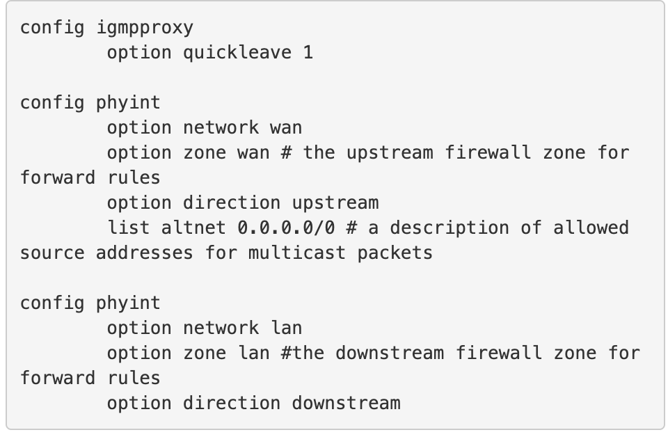

In the section config phyint, you might want to change the address after list altnet to 192.168.1.0/24. This refers to the description of allowed source addresses for multicast packets. The router’s ip address itself is 192.168.56.2. The other routers in the closed network for this routing protocol are 192.168.56.3 and 192.168.56.4. This might vary for your set up depending on how many routers are in your network, or which addresses you assign to your routers.

If you keep the address as 0.0.0.0/0 this means that any address will be allowed as a source.

Here is some more information about this configuration command:

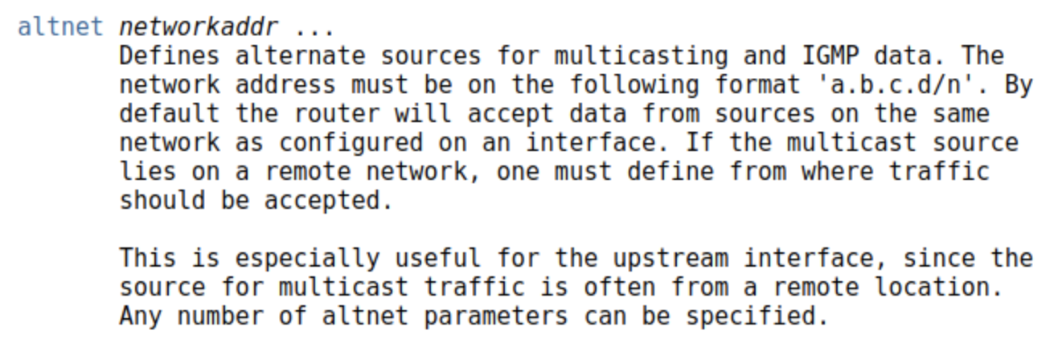

## Step 2: Avoid Flooding Your LAN

To avoid flooding all of the you will want to enable igmp snooping to your lan device.

Open **/etc/config/network/** and add the following to the file:

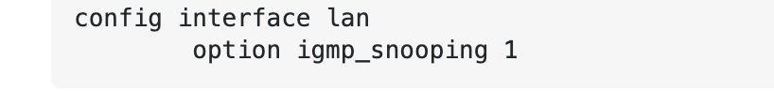

In order to enable this on br-mng, enter the following command:

**echo "0" > /sys/devices/virtual/net/br-lan/bridge/multicast_snooping**

## Step 3: Configure Firewall Settings

Open **/etc/config/firewall** and make sure it includes the following:

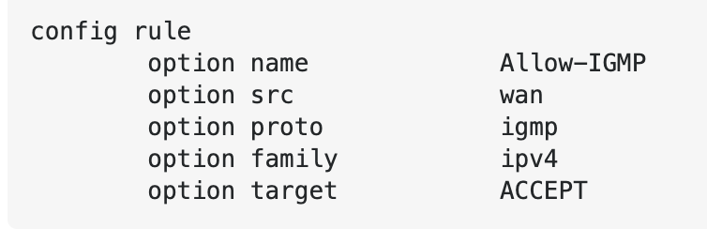

## Step 4: Add The Multicast Address to Your Device

To add the multicast address to your OpenWrt router, you will need to use the command

ip route add <address> dev <device name>. For you, this might look like:

**route add -net 224.0.0.0 netmask 224.0.0.0 br-mng** (for OpenWrt router)

**ip route add 224.0.0.0/4 dev eth0** (for non OpenWrt machine)

You can check if this has changed by running the command: **route -n** or **ifconfig**

In either of these commands, you should see the route added to the interface you specified.

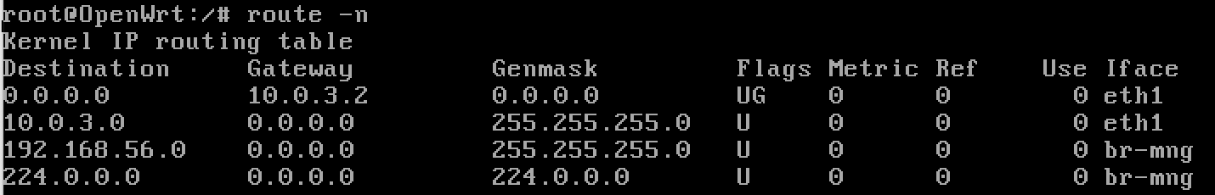

If you are unsure which device to add the route too, run the command **ifconfig** to find which device is using your ip address. For example:

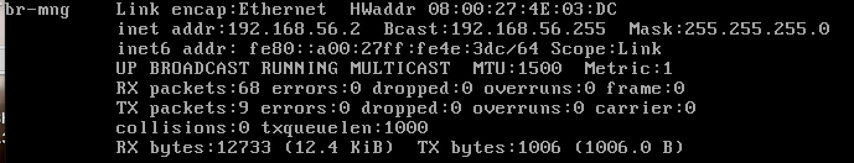

br-mng uses the ip address 192.168.56.2, so the device I want to use is br-mng.

[Here is more information about ifconfig!](https://www.networkworld.com/article/3058234/getting-the-most-from-ifconfig.html)

## Step 4: Restart Device to Use Address

In order for this change to take effect, you will need to restart your device using the following command.

**/etc/init.d/network restart**

You’re all set! You should be able to use multicasting :)